**DAILY ONLINE ACTIVITIES SUMMARY**

|  |  |  |  |  |  |  |
| --- | --- | --- | --- | --- | --- | --- |
| **Date:** | **21-05-2020** | | | **Name:** | **Nachiketh S Bhat** | |
| **Sem & Sec** | **6th - B** | | | **USN:** | **4AL17CS119** | |
| **Online Test Summary** | | | | | | |
| **Subject** | **OS** | | | | | |
| **Max. Marks** | **30** | | **Score** | | **30** | |
| **Certification Course Summary** | | | | | | |
| **Course** | **Machine learning with python** | | | | | |
| **Certificate Provider** | **Cognitiviclass.ai (IBM)** | **Duration** | | | | **8 of 10** |
| **Coding Challenges** | | | | | | |
| **Problem Statemen: 1** java program to implement round robin scheduling algorithm. calculate avg wt and tat. input: no of processes, burst time and time quantum **2.** java program to demonstrate a basic calculator using applet problem description we have to write a program in java such that it creates a calculator which allows basic operations of addition, subtraction, multiplication and division. **3**.c program to create singly liked list with n elements and reverse the elements. **4**. c program to construct a singly linked list by removing duplicate elements in the sorted linked list **5.**a simple applet java program to check whether the given number is armstrong number or not. **6**. Python program in number right angled triangle | | | | | | |
| **Status: executed** | | | | | | |
| **Uploaded the report in GitHub** | | **yes** | | | | |
| **If yes Repository name** | | <https://github.com/nachi0106/Daily-Activity/tree/master/Online-coding%20report/21-05-20> | | | | |
| **Uploaded the report in slack** | | **Yes** | | | | |

Online Test Details:

First I A of OS

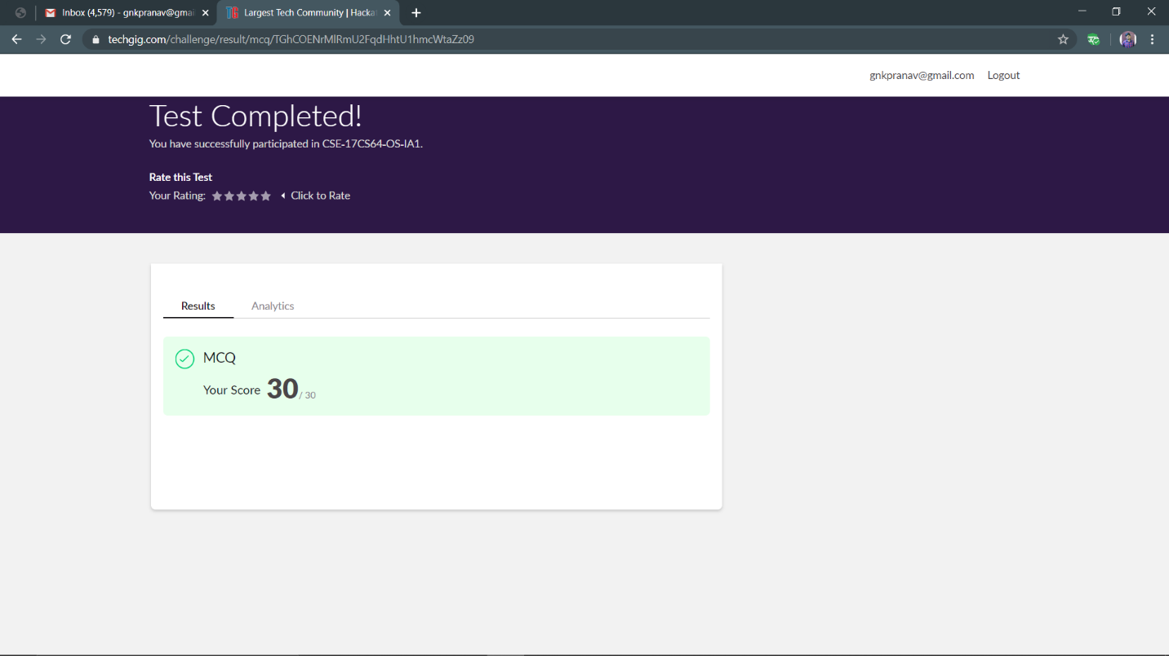

Certification Course Details:

Topic covered

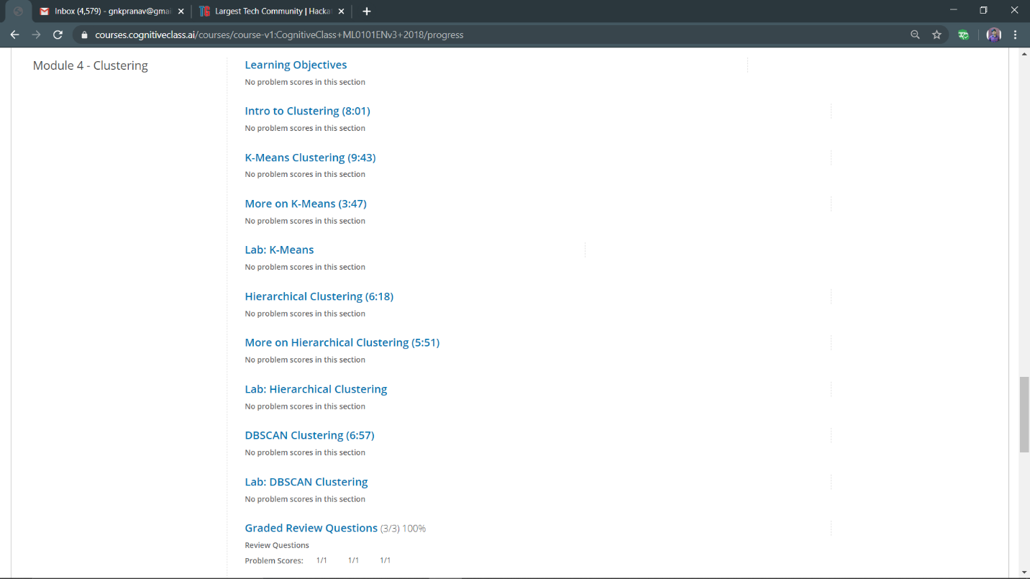

Progress:

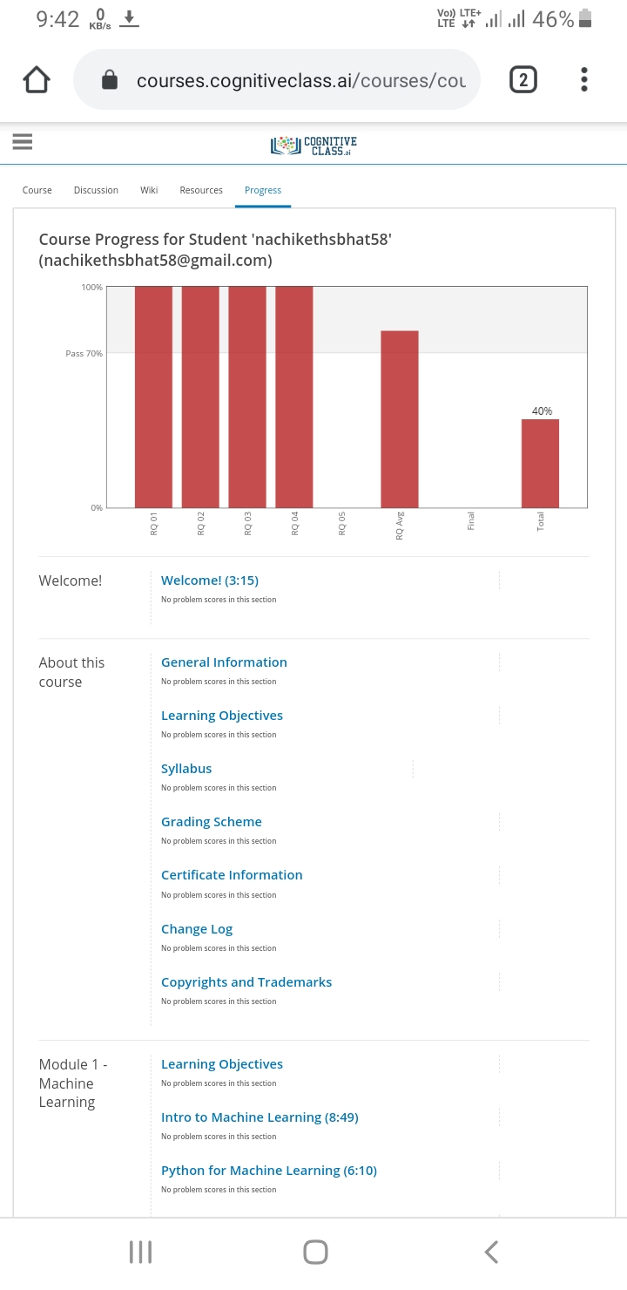

Coding Challenges Details:

The below gitHub link for details

<https://github.com/nachi0106/Daily-Activity/tree/master/Online-coding%20report/21-05-20>

1

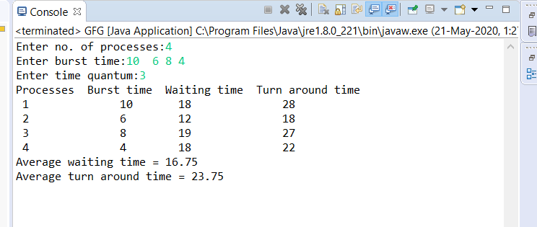

2

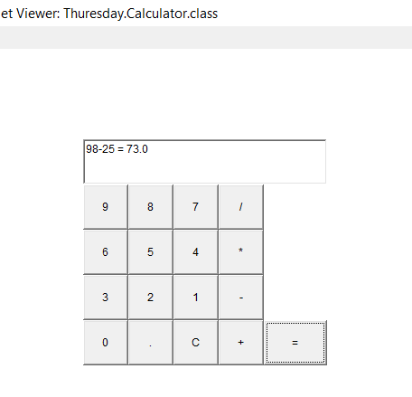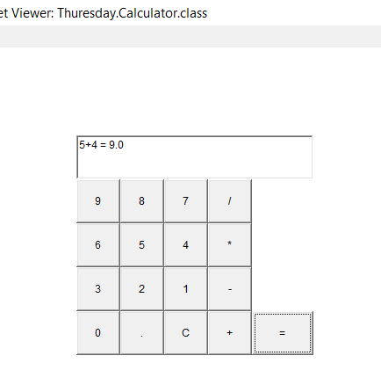 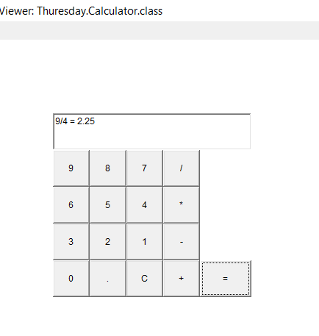

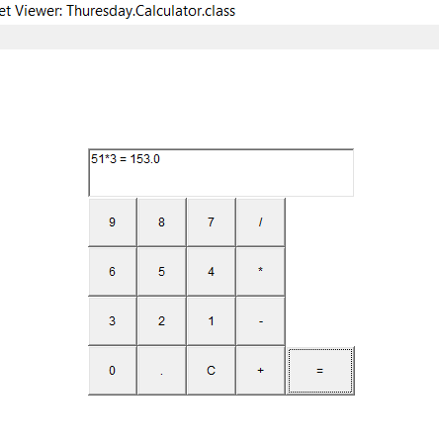

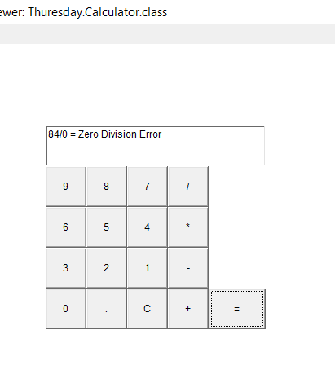

3

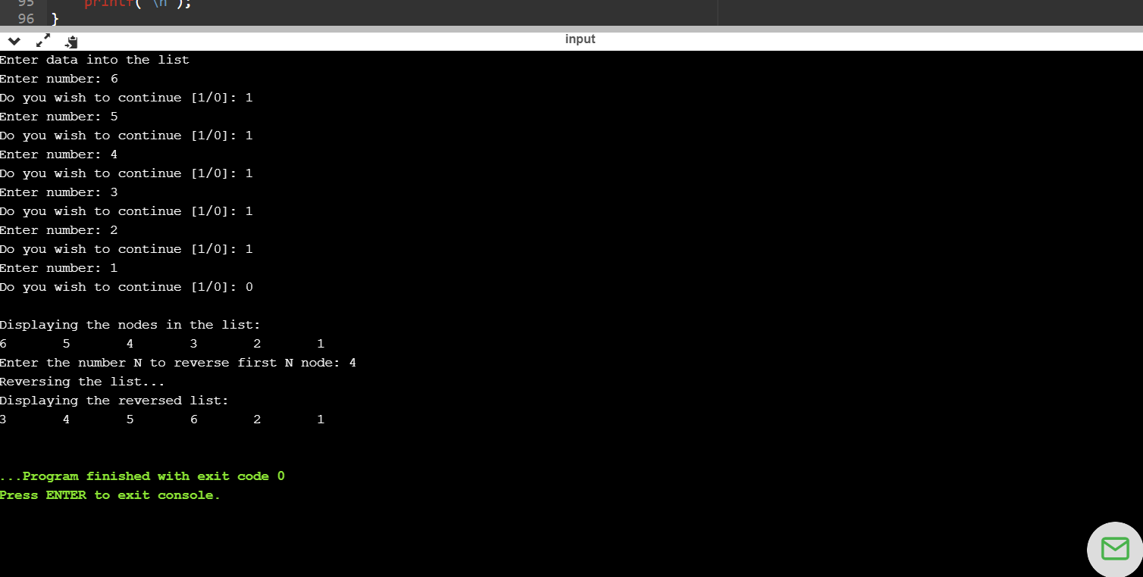

4

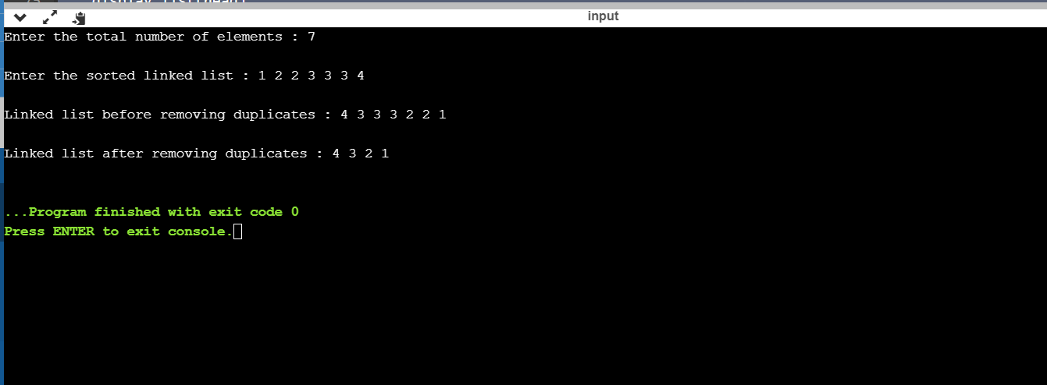

5

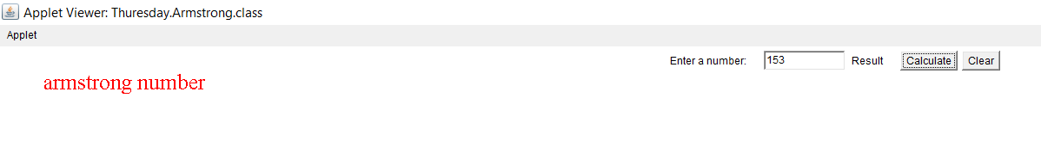

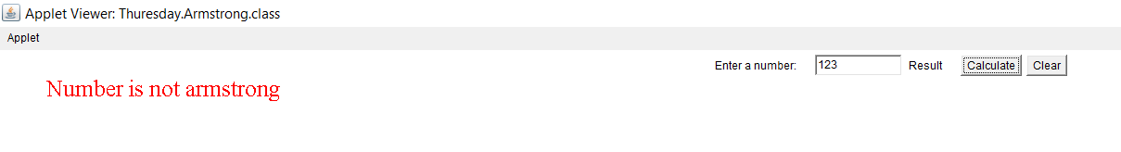

6

